|  |  |  |  |
| --- | --- | --- | --- |
|  | Bansilal Ramnath Agarwal Charitable Trust's  Vishwakarma Institute of Information Technology  **Department of**  **Artificial Intelligence and Data Science** | | |
| Name: Siddhesh Dilip Khairnar | | | |
| Class: SY | Division: B | | Roll No: 272028 |
| Semester: IV | | Academic Year: 2022-2023 | |
| Subject Name & Code: ES22201AD: Probability and Statistics | | | |
| Title of Assignment: Linear Regression in R | | | |
| Date of Performance: 27-04-2023 | | Date of Submission: 27-04-2023 | |

**ASSIGNMENT NO. 8**

**Background information:**

Linear regression is a statistical method used to model the relationship between a dependent variable and one or more independent variables. In other words, it is used to find the linear relationship between two or more variables by fitting a linear equation to the observed data.

In R, the `lm () ` function is used to perform linear regression. Here is an example of how to perform a simple linear regression in R:

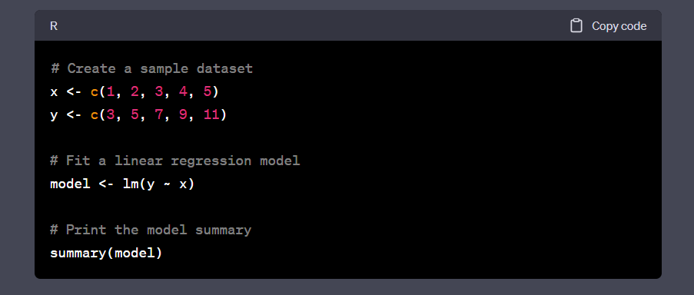

In this example, we have created a simple dataset with two variables, `x` and `y`. We then fit a linear regression model to the data using the `lm()` function, with `y` as the dependent variable and `x` as the independent variable. The `summary ()` function is used to print out a summary of the model, which includes information such as the intercept, the slope of the line, and the R-squared value.

Here are some other important terms to understand when working with linear regression:

- Coefficients: These are the values that represent the slope and intercept of the line in a linear regression equation. In R, you can access the coefficients of a linear regression model using the `coefficients () ` function.

- Residuals: These are the differences between the predicted values of the dependent variable and the actual values. In R, you can access the residuals of a linear regression model using the `resid () ` function.

- R-squared value: This is a measure of how well the linear regression model fits the data. It represents the proportion of the variance in the dependent variable that is explained by the independent variable(s). In R, you can access the R-squared value of a linear regression model using the `summary () ` function.

Here is an example of how to use these functions to analyze a linear regression model:

In addition to simple linear regression, R can also be used to perform multiple linear regression (with more than one independent variable), polynomial regression (to model non-linear relationships), and logistic regression (to model binary outcomes). The process for fitting these models is similar to that of simple linear regression, but the specific functions and arguments used may differ.

**

**Conclusion:** We have successfully implemented linear regression in RStudio.